Dolgin Debuts 2-Position Battery Charger for Canon's C300 Mk II Cameras
August 15, 2016
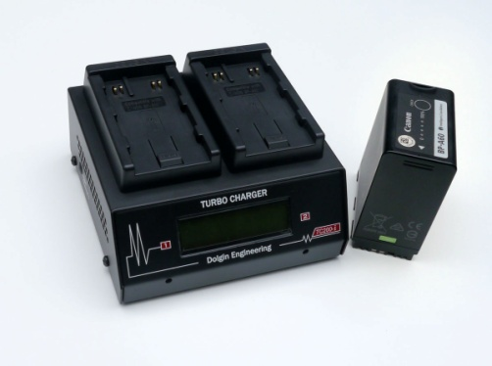
Lexington, MA – Dolgin Engineering, a leading provider of fast multi position battery chargers and DC power adapters announced the release of a new smart 2-position battery charger TC200-CAN-A60-i.
Designed for video production studios and rental facilities, the unit is designed to provide fast, reliable charging of multiple camera batteries for both in-house and field use.
The TC200-CAN-A60-i incorporates a host of key features including:
- Fast, safe simultaneous charging of BP-A60 and BP-A30 packs.
- Compatible with non-OEM batteries.
- Digital LCD display indicates the battery pack capacity.
- As a battery is being charged, charge status is displayed in Volts, Ah, and percent of charge
- Each of the 2 channels is fully independent of the other.
- Auto-detecting, fast charging USB port for recharging tablets, handsets, personal media players and other portable devices (Apple, Android, etc).
Works when AC power is available and on-the-go when at least one charged battery is available.
- Worldwide 100-240V AC power.
- Sleek, small and lightweight package (WxHxD) 5.4" x 2.0" x 5.2".
- Designed and manufactured in the USA.
- Warranty 2 years parts and labor.
The TC200-CAN-A60-i also features a highly efficient smart charging circuit. “It takes only about 5 hours to charge a high capacity battery pack. The pack can be left on the charger after the charge is complete,” said Dolgin.
For more information visit Dolgin Engineering www.dolgin.net or call (781) 863-1813

