Dolgin Debuts 4-Position Battery Charger for Canon's C300 Mk II Cameras
August 15, 2016
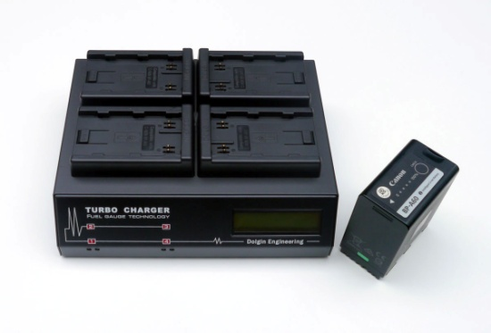
Lexington, MA – Dolgin Engineering, a leading provider of fast multi position battery chargers and DC power adapters announced the release of a new 4-position battery charger for Canon's C300 Mk II camera family.
Designed for video production studios and rental facilities, the unit is designed to provide fast, reliable charging of multiple BP-A60/A30 camera batteries for both in-house and field use.
According to company president Alex Dolgin, “Due to the great success of our TC400 charger line, we’ve responded to numerous requests for a 4-position charger for the new Canon's C300 Mk II Cameras”.
The TC400-CAN-A60 incorporates a host of key features including:
- Fast, safe simultaneous charging of BP-A60 and BP-A30 packs.
- Digital LCD display indicates the battery pack capacity.
- As a battery being charged, charge status is displayed in Volts, Ah, and percent of charge
- Each of the 4 channels is fully independent of the other.
- Worldwide 100-240V AC power.
- Sleek, small and lightweight package (WxHxD) 8.4" x 2.5" x 6.6".
- Designed and manufactured in the USA.
The TC400-CAN-A60 also features a highly efficient smart charging circuit. “It takes only about 5 hours to charge a high capacity battery pack. The pack can be left on the charger after the charge is complete,” said Dolgin.
For more information visit Dolgin Engineering www.dolgin.net or call 781 863-1813

